Assignment Activity 17.1: Using NiFi to Connect to an Excel File

1. A screenshot to show that the two folders: input and output successfully created.

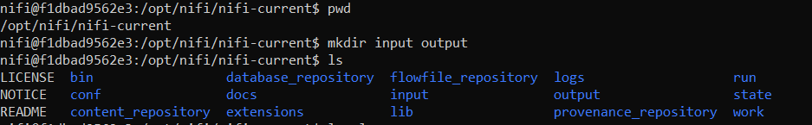

1. A screenshot of the Activity 17_1 excel file location in NiFi container.



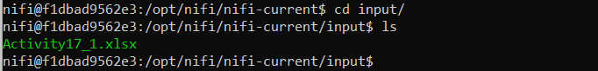

1. A screenshot to show that of NiFi opened from the browser.

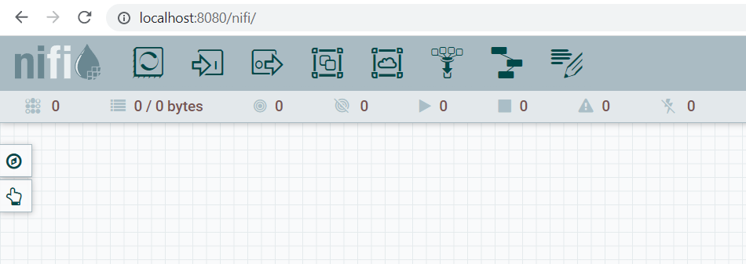

1. A screenshot to show that you successfully created the new Activity17.1 process group.

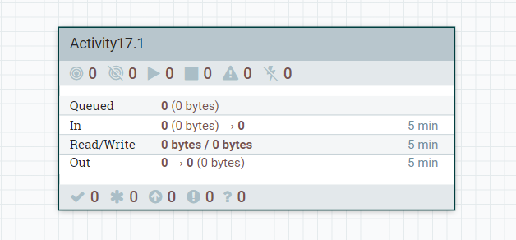

1. A screenshot to show that the ConvertExcelToCSVProcessor processor successfully added to the NiFi canvas.

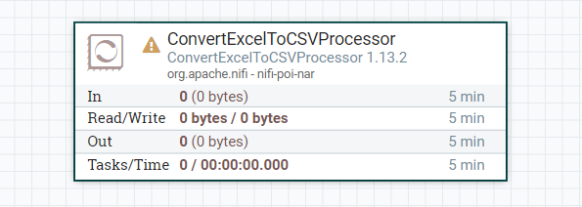

1. A screenshot to show that the properties for the ConvertExcelToCSVProcessor processor configured correctly.

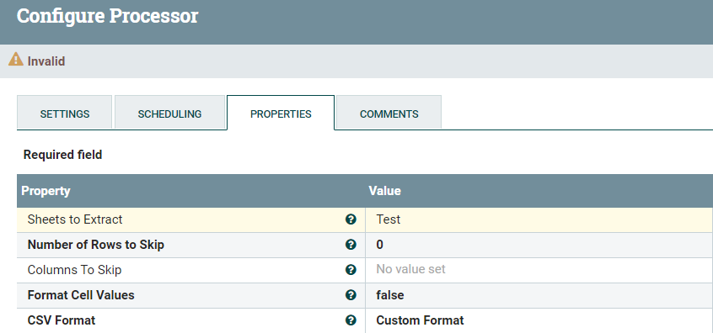

1. A screenshot to show that you successfully added the GetFile processor to the NiFi canvas.

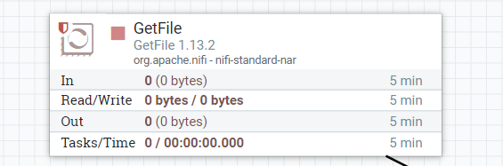

1. Two screenshots. The first screenshot should show that the values set in the PROPERTIES tab correctly. The second screenshot should show that the scheduling time updated in the SCHEDULING tab correctly.

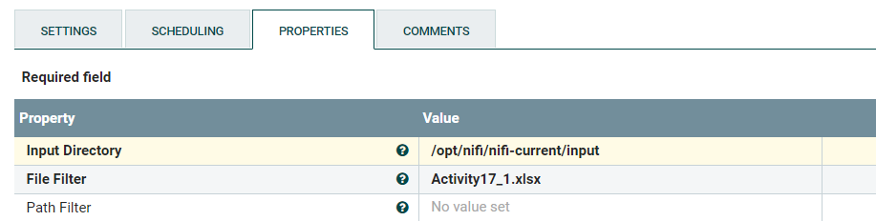

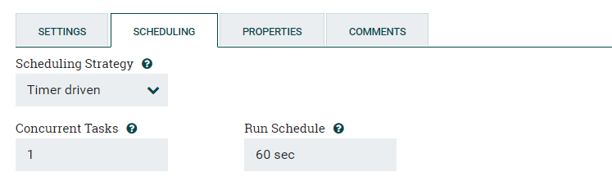

1. A screenshot to show that the PutFile processor successfully added to the NiFi canvas.

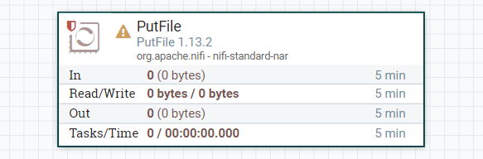

1. Two screenshots. The first screenshot should show that the values in the PROPERTIES tab set correctly. The second screenshot should show that the scheduling time updated in the SETTINGS tab correctly.

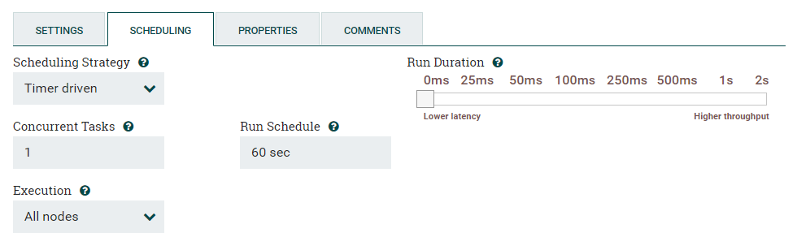

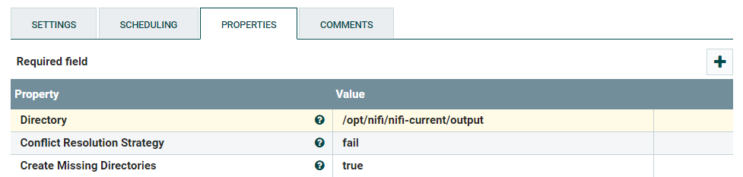

1. A screenshot to show that you successfully connected the GetFile and ConvertExcelToCSVProcessor processors.

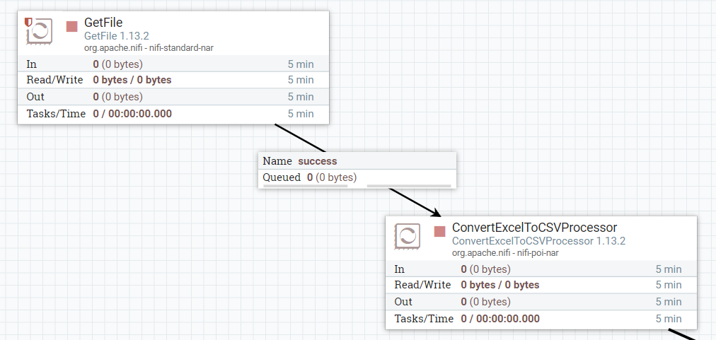

1. A screenshot to show that you successfully connected the ConvertExcelToCSVProcessor and PutFile processors.

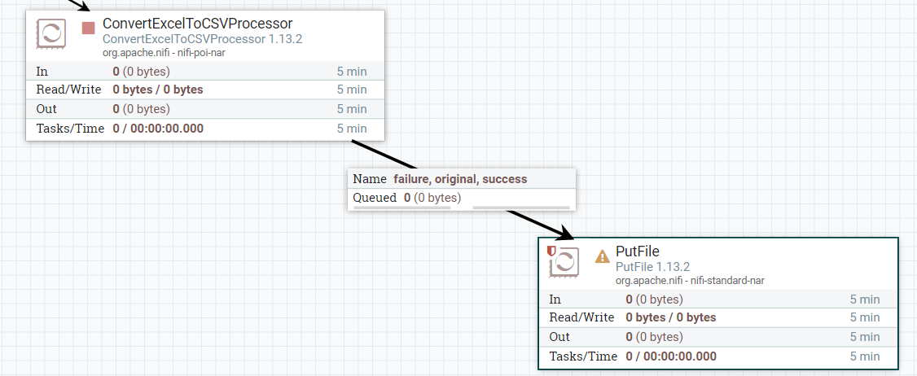

1. Two screenshots. The first screenshot should show that the GetFile processor is running (as indicated by a green arrow). The second screenshot should show that the input folder is empty (i.e., that the GetFile processor has picked up the file from the input folder for processing).

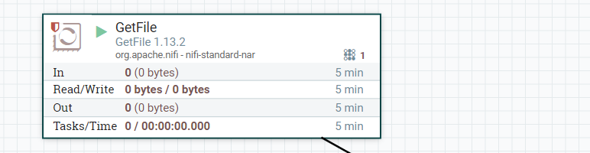

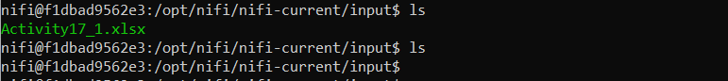

1. A screenshot to show that the ConvertExcelToCSVProcessor processor is running (as indicated by a green arrow).

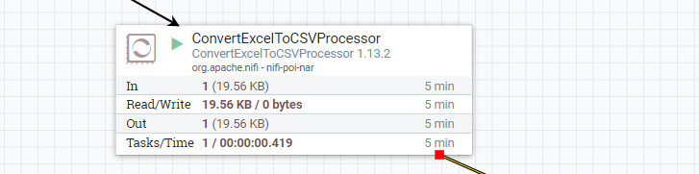

1. A screenshot to show that the PutFile processor is running (as indicated by a green arrow).

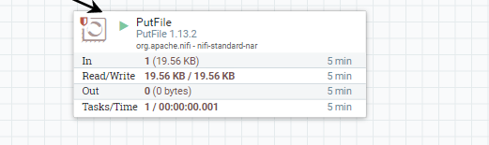

1. A screenshot to show that the CSV file has been created.

